Maharashtra Education Society’s

Institute of Management and Career Courses (IMCC), Pune

AUTONOMOUS

**AY 2024-2025**

**MCA Semester-III Course: ITC31 Mini Project**

**Index**

|  |  |  |
| --- | --- | --- |
| **Chapter No** | **Description** | **Page Number** |
| **1** | * **Introduction** * **Scope of System** |  |
| **2** | * **Proposed System** * **Study of Similar Systems** |  |
| **3** | * **Entity Relationship Diagram (ERD)** * **Use Case Diagrams** * **Activity Diagram** |  |
| **4** | * **Database Design** * **Table Structure/ Data Dictionary** |  |
| **5** | * **Test Design** * **Test Cases** |  |



Dr. Shweta Meshram

Coordinator, Mini Project

**Chapter 1**

# Introduction

The TNP Event Planner is a web application designed to facilitate event planning for an event planning company, ENP Event Planner. This project showcases the capabilities of ReactJS in building a static yet interactive user interface, using Docker for containerization and Git for version control. Users can book events, inquire about job opportunities, and interact with various sections of the site through a user-friendly navigation bar. .

# Project Scope

* + **User Interaction**: Register, login, and manage user sessions.
  + **Event Booking**: Stream music with play, pause, next, previous, shuffle, and repeat options.
  + **Career Opportunities**: Search for songs, albums, and artists with suggestions.
  + **Content Display**: Create, edit, delete playlists; add/remove songs

## Technical Scope

* + - **Frontend Development**: • Use ReactJS for building the user interface.
    - **Form Handling**: Integrate Google Forms for event booking and career application forms.
    - **Static Content**: Provide static content for various informational pages without backend or database integration.
    - **Containerization**: Use Docker to containerize the application for consistent development, testing, and deployment environments.
    - **Version Control**: Utilize Git for version control to manage changes and collaborate on the project.
    - **Deployment**: Deploy the website for public access.

**Limitations and Exclusions**

* + - **No Dynamic Backend:** The project does not include dynamic content fetching or database integration.
    - **No Backend Development:** Excludes any server-side processing or database management.
    - **Limited Interactivity:** The focus is on static content with limited interactivity through forms.

**Proposed System**

The proposed system is a web application for ENP Event Planner, providing an interactive and static user experience. Users can book events, explore services, view career opportunities, read the blog, and contact the company.

## System Architecture

The system follows a client-side architecture with the following components:

***Client-Side (ReactJS Application)***

* + - **User Interface (UI):** Developed using ReactJS for responsive and dynamic UI elements.
    - **Navigation Bar:** Allows users to navigate through Home, About Us, Services, Career, Blog, and Contact Us pages.
    - **Forms:** Integrates Google Forms for event booking and career applications.
    - **Static Content:** Displays static information on various pages.

## External Services

* + - **Google Forms**: Used for collecting user inputs for event booking and career applications.

**Containerization (Docker)**

* + - **Docker:** Containerizes the application for consistent development, testing, and deployment environments.

**Version Control (Git)**

* + - **Git:** Manages changes and collaboration on the project through version control.

## 4. Study of Similar System:

Event Planning Websites

Overview: Event planning websites offer similar functionalities such as event booking, service listings, and contact forms.

**Key Features:**

* + - **Event Booking**: Users can book events by providing necessary details.
    - **Service Listings**: Detailed information about available services.
    - **Contact Forms**: Forms to get in touch with the company for inquiries.
    - Technologies Used:
    - **Frontend**: Typically built with HTML, CSS, JavaScript, and frameworks like ReactJS or Angular.
    - **Forms**: Integration with services like Google Forms for data collection.
    - **Containerization**: Use of Docker for consistent deployment environments.
    - **Version Control**: Use of Git for managing code changes and collaboration.

# Chapter 2

# Project Modules

1. **Landing Page Module:**

Description: The initial page users see when they visit the platform.

Components:

• Featured Products Display

• Search Bar

• Product Categories

• Links to Individual Product Descriptions

1. **Sell a Product Module:**

Description: Allows admin to list products for sale.

Components:

• Product Listing Form

• Image Upload

• Listing Confirmation

1. **Search for a Product Module:**

Description: Search for a specific product or related product.

Components:

• List of related products.

• Product Images

• Product Description

• Price

• Add to Cart Button

1. **Shopping Cart Module:**

Description: Manages items added by buyers for purchase.

Components:

• Cart Page

• Cart Summary

• Proceed to Checkout

1. **Payment Module:**

Description: Manages payment methods of the users.

Components:

• Redirection to payment app

• Confirmation of payment

• Generation of invoice

# Chapter 3

# Use case Diagram

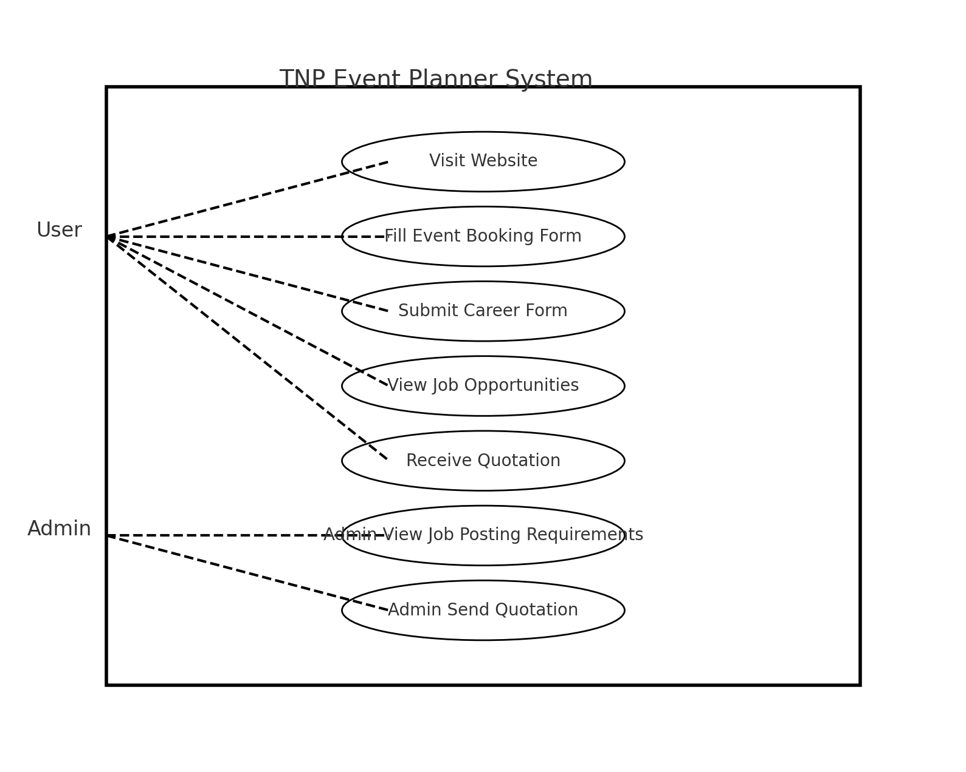

# Class Diagram

# User Interface

# Homepage Design

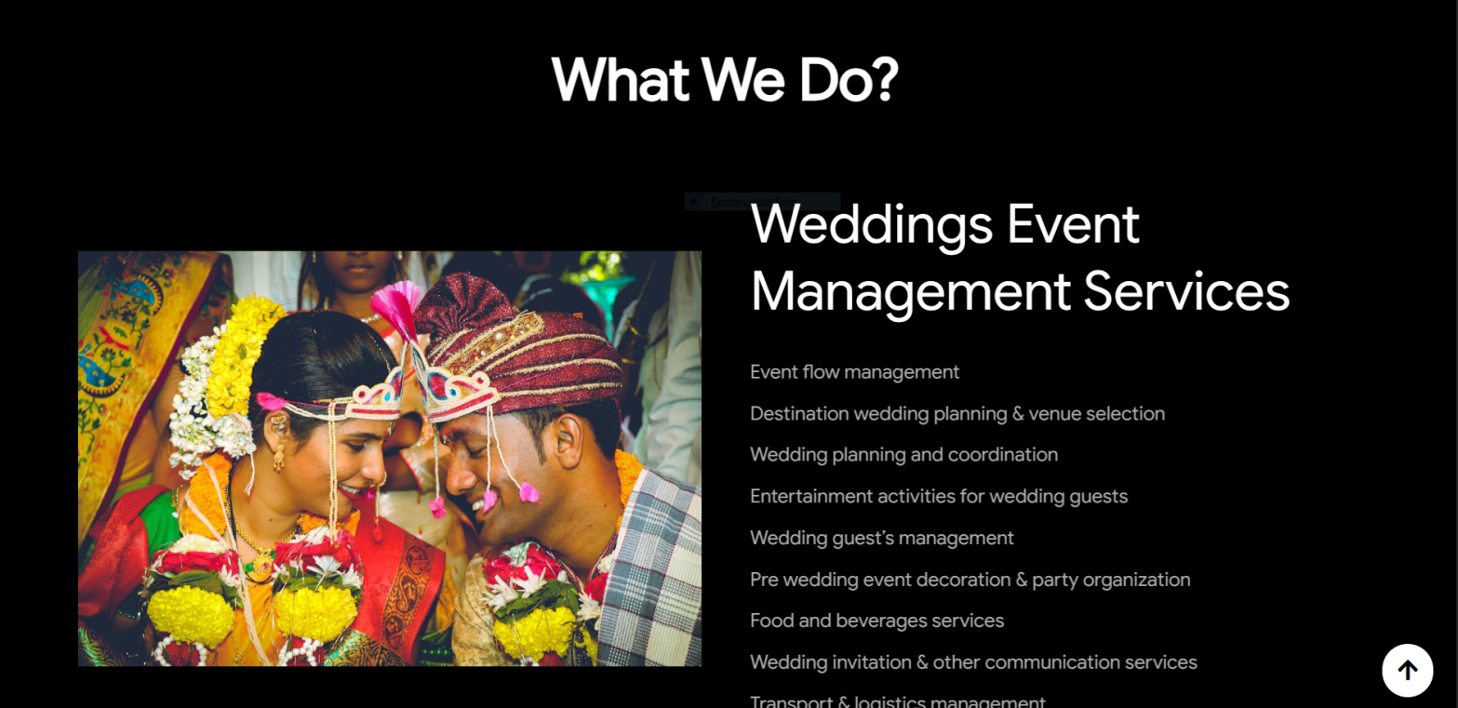

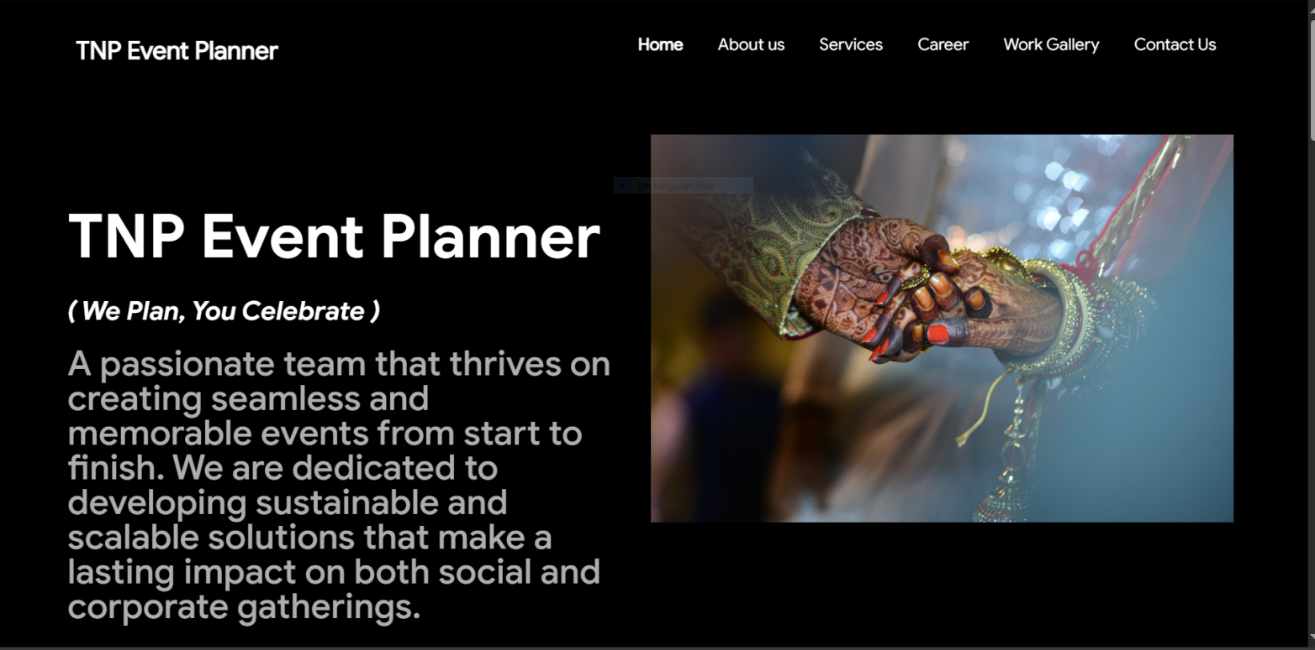

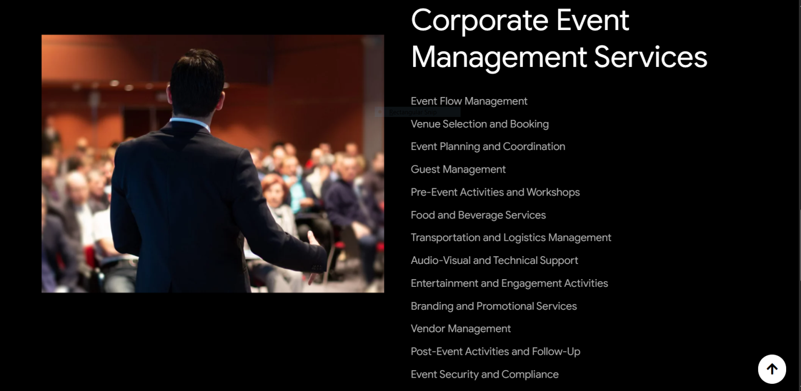

# About Us page Design

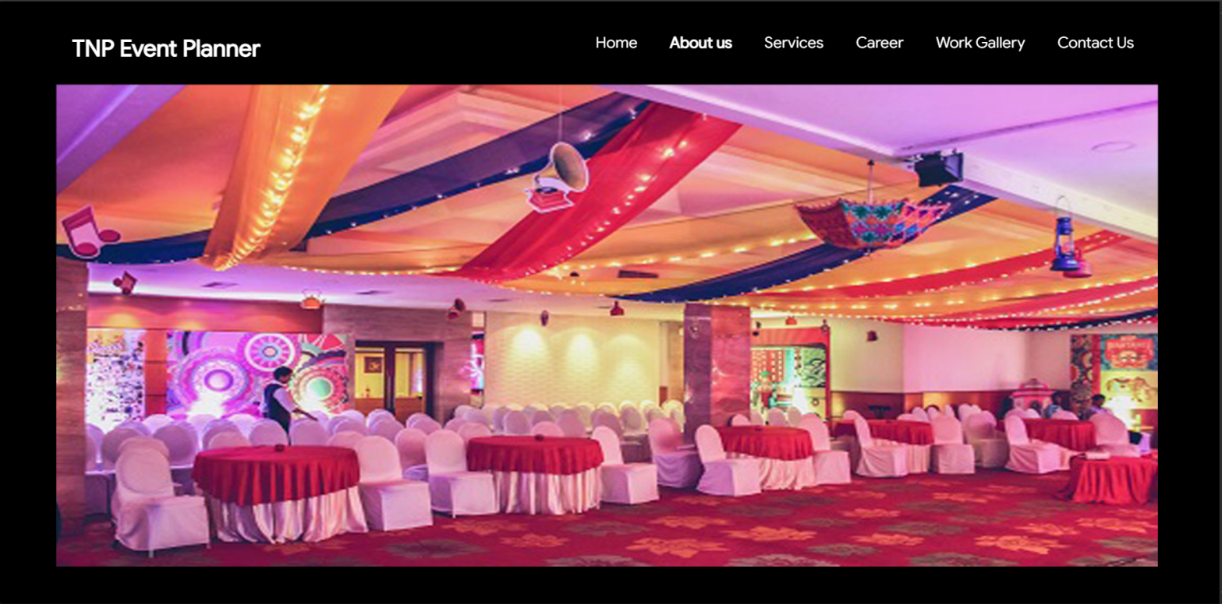

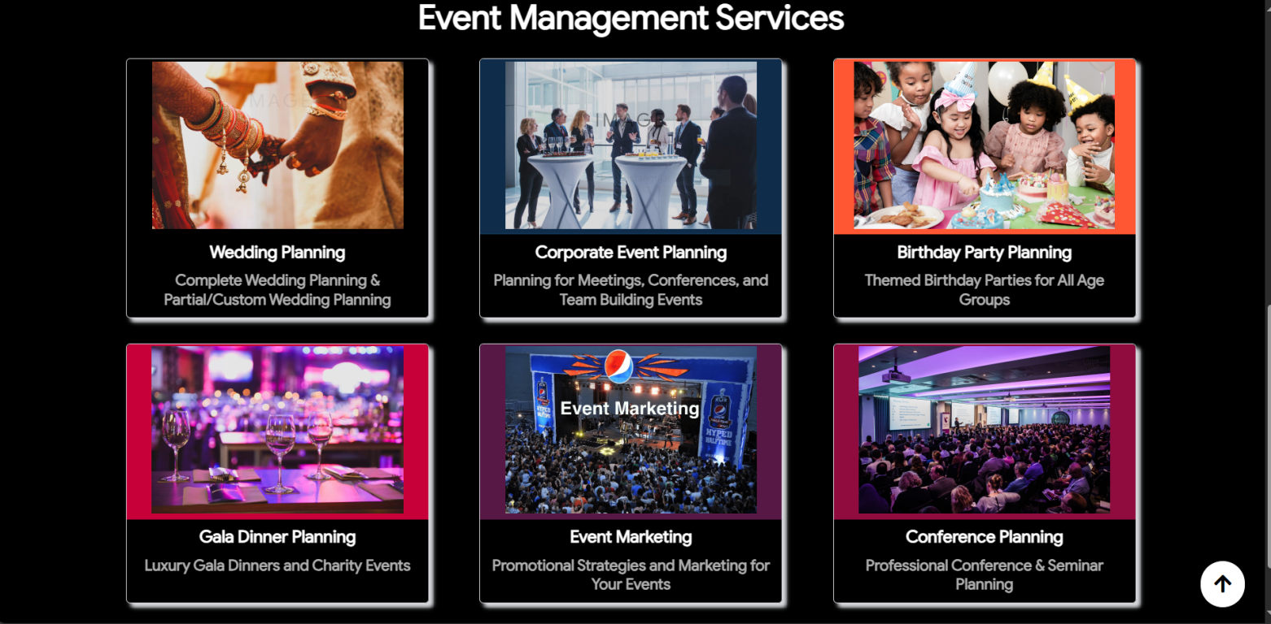

# Services page Design

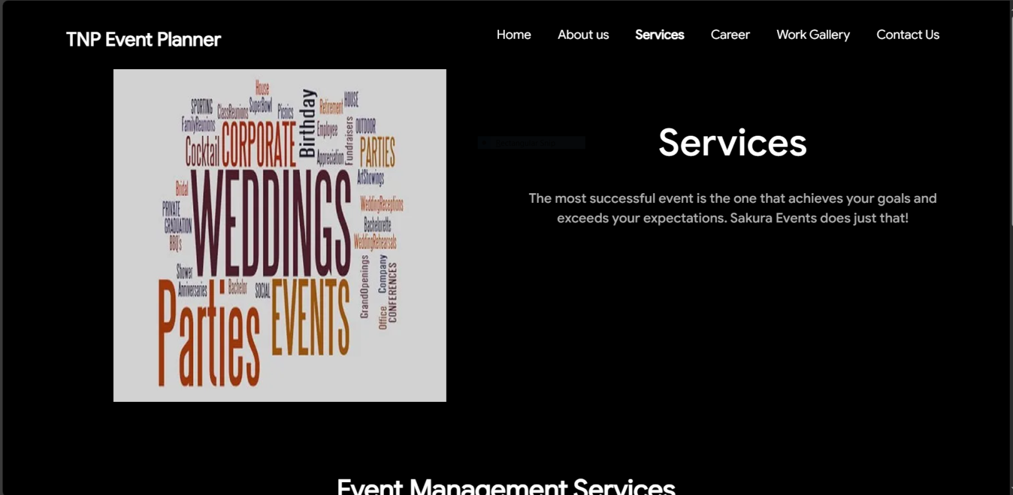

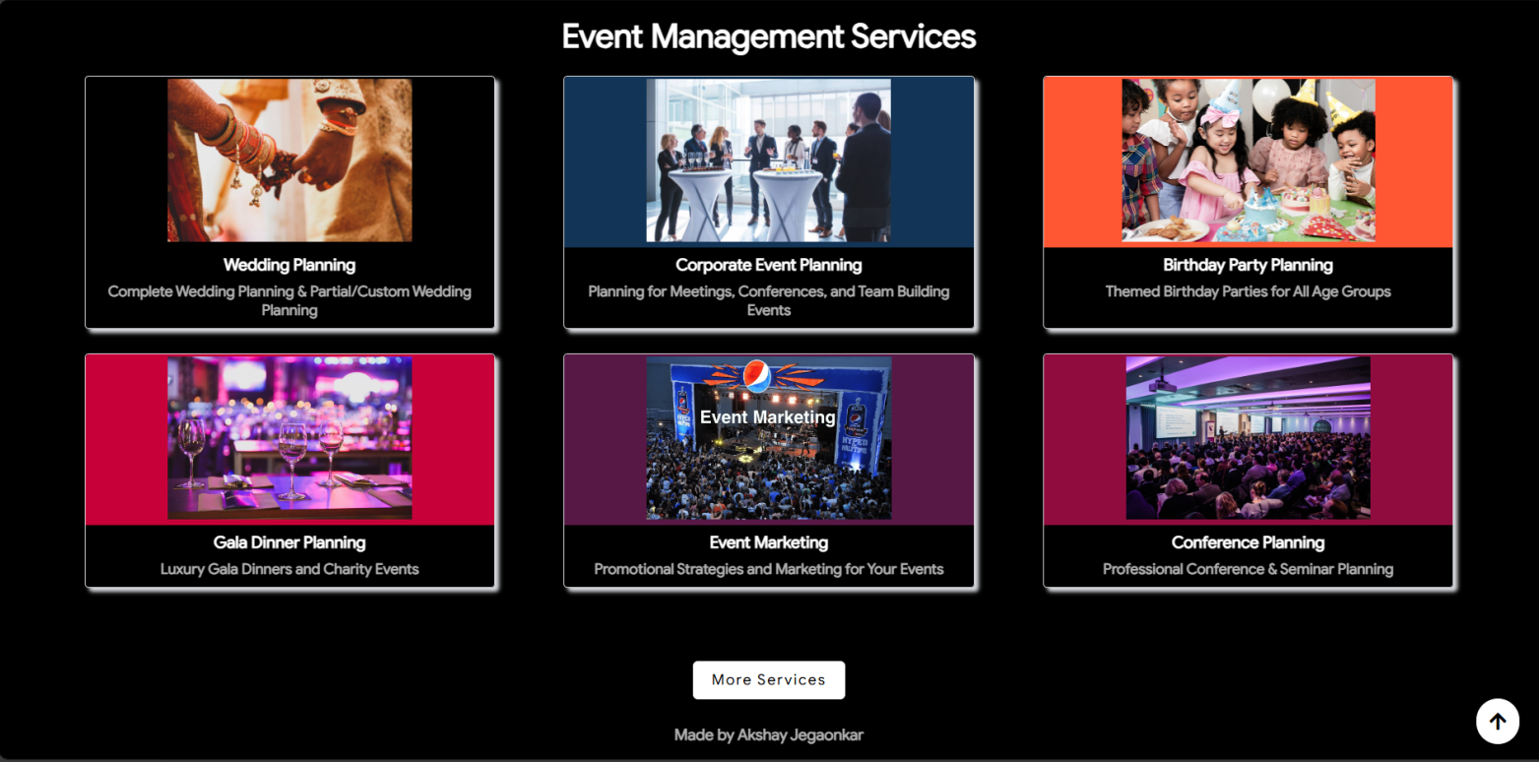

# Career page Design

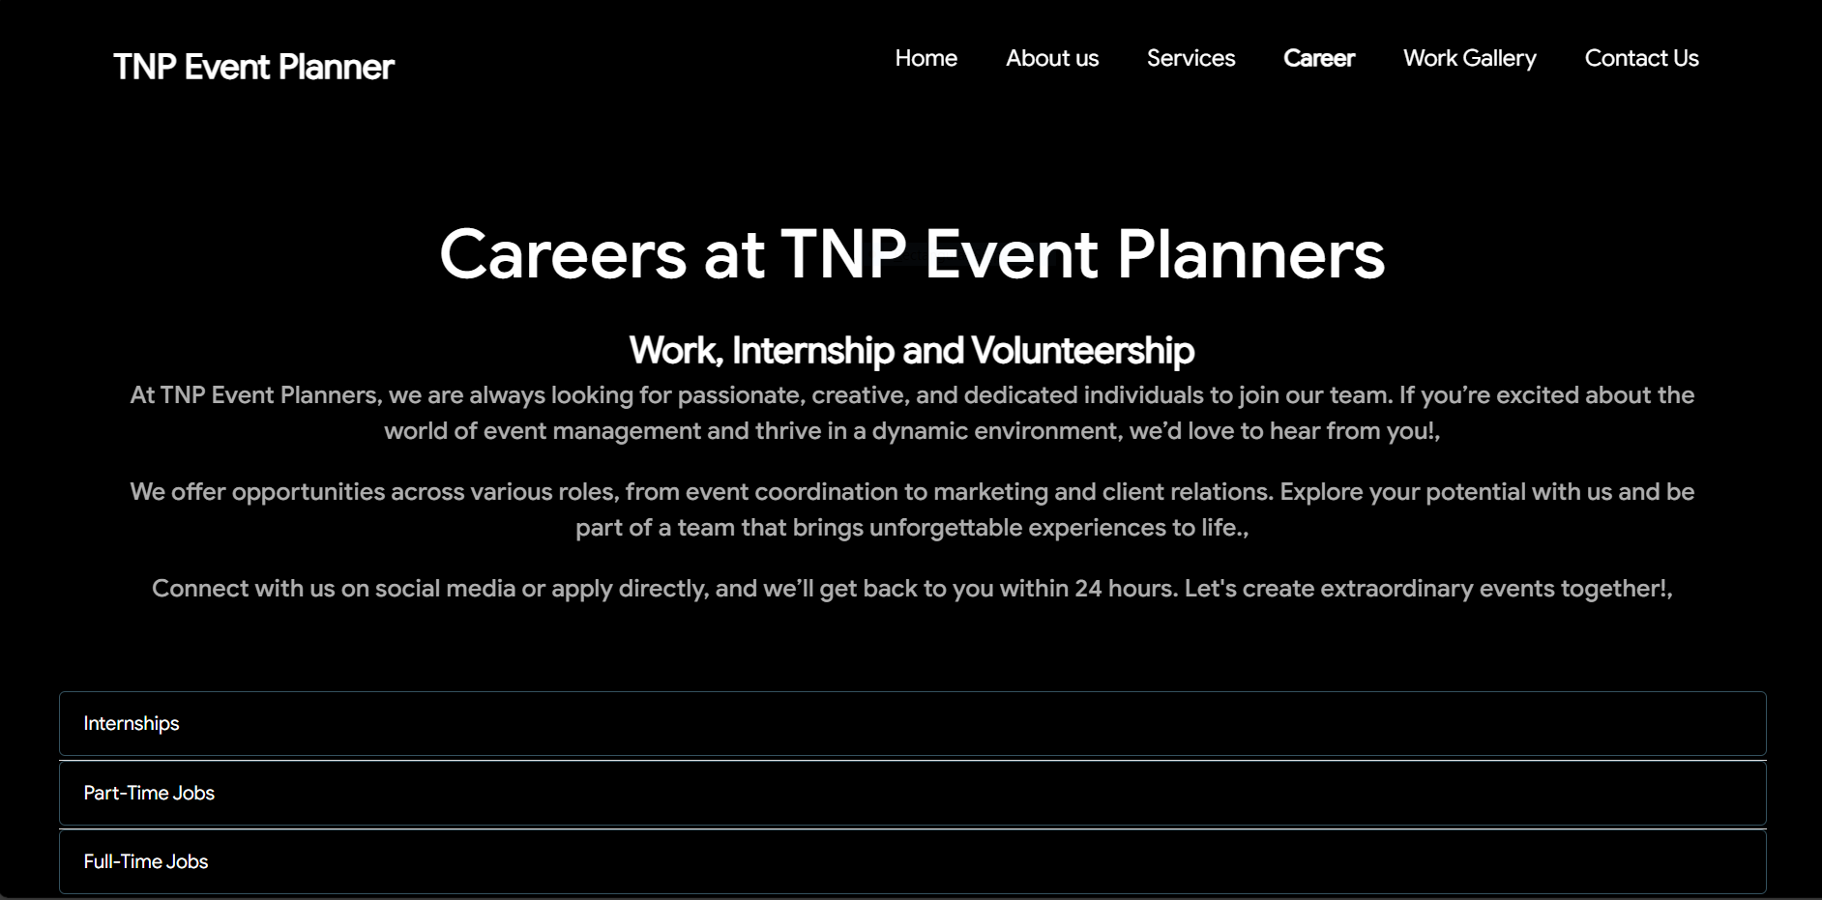

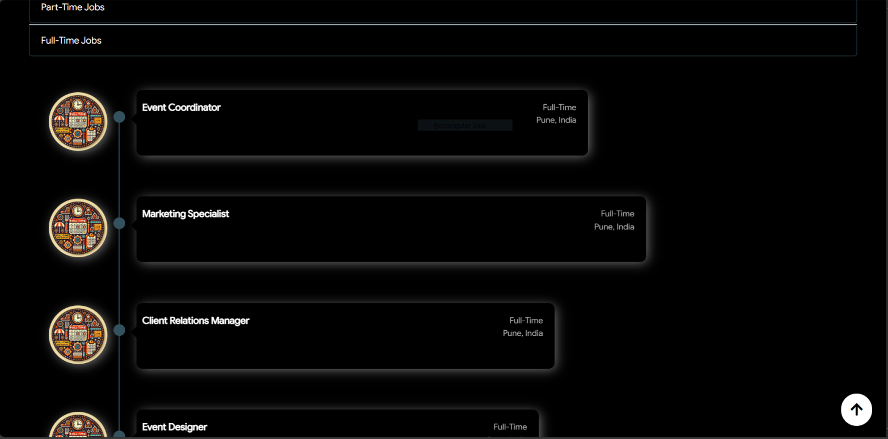

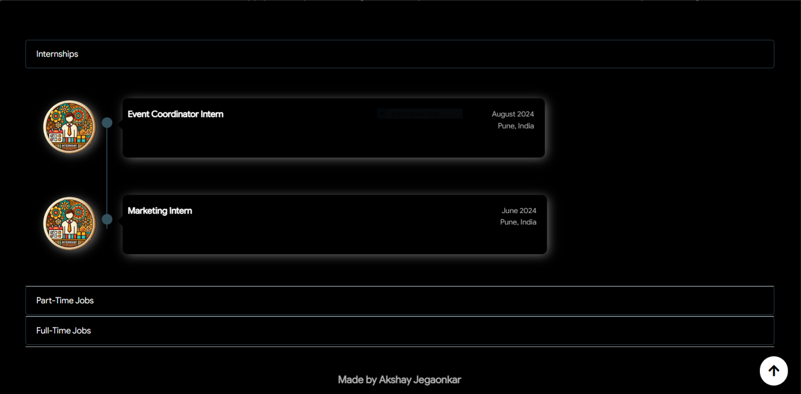

# Work Gallery Page Design

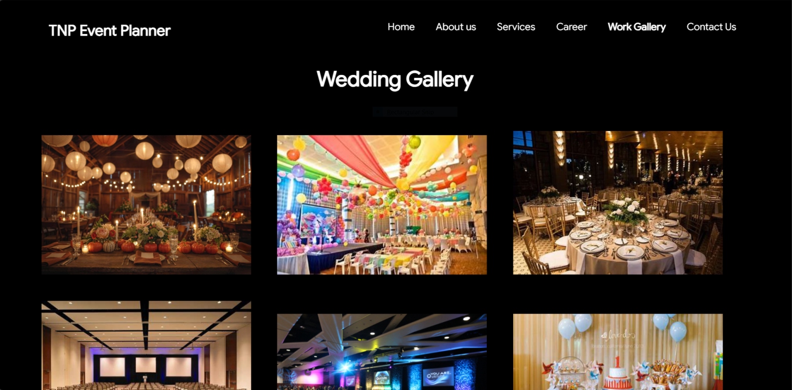

# Contact Us Panel

# 

# 

# 

# Chapter 3

#### Test Case 1: Navigate to Home Page

* + ***Precondition:*** *User is on any page other than Home.*
  + ***Test Steps:*** *Click on the "Home" link in the navigation bar.*
  + ***Expected Result:*** *User is redirected to the Home page.*

#### Test Case 2: Navigate to About Us Page

* + ***Precondition:*** *User is on any page other than Services.*
  + ***Test Steps:*** *Click on the "Services" link in the navigation bar.*
  + ***Expected Result:*** *User is redirected to the Services page.*

#### Test Case 3: Navigate to Services Page

* + ***Precondition:*** *User is on any page other than Career.*
  + ***Test Steps:*** *Click on the "Career" link in the navigation bar.*
  + ***Expected Result:*** *User is redirected to the Career page.*

#### Test Case 4: Navigate to Career Page

* + ***Precondition:*** *User is on any page other than Blog.*
  + ***Test Steps:*** *Click on the "Blog" link in the navigation bar.*
  + ***Expected Result:*** *User is redirected to the Blog page.*

#### Test Case 5: Navigate to Blog Page

* + ***Precondition:*** *User is on any page other than Contact Us.*
  + ***Test Steps:*** *Click on the "Contact Us" link in the navigation bar.*
  + ***Expected Result:*** *User is redirected to the Contact Us page.*

#### Test Case 6: Navigate to Contact Us Page

* + ***Precondition:*** *User is on any page other than Contact Us.*
  + ***Test Steps:*** *Click on the "Contact Us" link in the navigation bar.*
  + ***Expected Result:*** *User is redirected to the Contact Us page.*